**Website Structure and Navigation**

User types

* Administrator
* Log-In User
* Guest User

**Functional requirement list**

* Search - all users have access to this function.
* Basket - administrator can view the basket and view pending orders but can’t add to the basket.
* Shopping function - Only a logged in user can purchase things. Guest users can only browse.

**Structure Diagram**

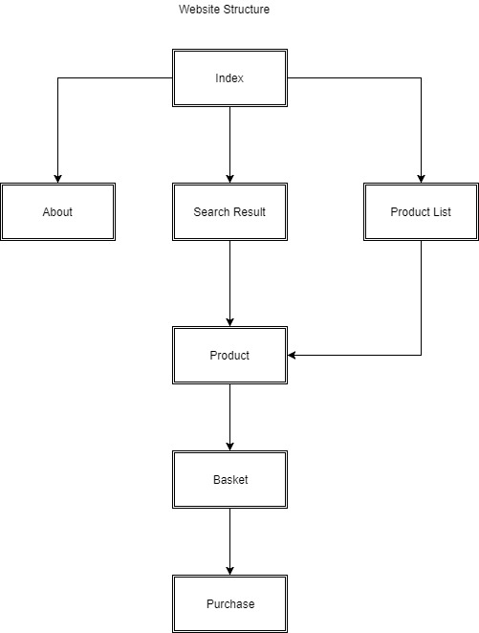

|  |  |  |
| --- | --- | --- |
| Name of element | Description and links | Included in pages |
| Main navigation bar | Hierarchical navigation bar with the following elements and indentations:  Home (target: index.html)  About (target : about.html)  Search (target :search.html)  Product (target: product.html)  Basket (target: basket.html)  Purchase (target:purchase.html) | All |
| Checkout button | Proceed to checkout (target:purchase.html) | basket.html |
| Product Dropdowns (See Design in 1b document) | List with links to products (target: product.html) | productlist.html  search.html |

**Contributions**

* Structure Diagram done by Aoife.
* Navigation element table done by Rachel.
* Functional requirement list done by Jordan.
* Website Structure and Navigation done by all.